Overall Game Play:

You rotate the back ground, changing directions of gravity in order to get through the door which completes each level.

Progress: Complete levels

The game’s designed age range is 12-60

Story:

なに

おまいわもしんている

Techniques:

: Jump

: Move left

: Move right

Left Arrow: Move world to the left

Right Arrow: Move world to the right

In game objects:

Harmless:

Platforms: you can stand on them and they are not controlled by gravity

Blocks: you can stand on them and they are affected by gravity

Exit Area: Self explanatory

Buttons: Works same as switch but has delay after

One-Step-Platform: Restores after a couple seconds

Sticky Surface: You are stick to the surface and not affected by gravity.

Jump pad: Self explanatory

Harmfull:

Spikes: Stay at one spot and kills you if you touch it

Falling spikes: Can be affected by gravity

Moving spikes: Spikes that move around

Cpu: Cannot be killed and moves around in a certain path (Moving turrets)

Level groups:

Melee troop

For each level, the gravity direction changes and gravity strength changes

Challenges

Challenges are things that give you a certain mission for a level. If you complete the mission with the challenges completed you are rewarded with trophies.

Challenges:

Time: Finish the mission in a certain amount of time.

Switch scenes: Finish the mission by switching certain times of gravity

Zero death: self explanatory

Boss

Bosses is a scenario that occurs when you reach a certain level and an object tries to stop you for the entire level.

Boss levels occur every 5 levels.

PreBoss:

Boss chases you and 1 button on wall.

Boss 1:

Level 4, boss chases you and kills you on contact, the level has spikes going in circle. Player may utilize the spikes to kill boss

Boss 2:

Level 7, boss fires machine gun bullets at player while the boss spawns turrets boss has guiding bullets.

Boss 3:

Level 10, boss has the ability to alter direction of gravity, try to save yourself by rotating screen. Boss slowly dies from exhaustion

Boss 4:

Level 14, Complicated boss

Can use gravity to push platforms of spikes together

The boss mainly utilize spikes to his advantage

Stand on spikes other side to avoid it

Levels

Level 1:

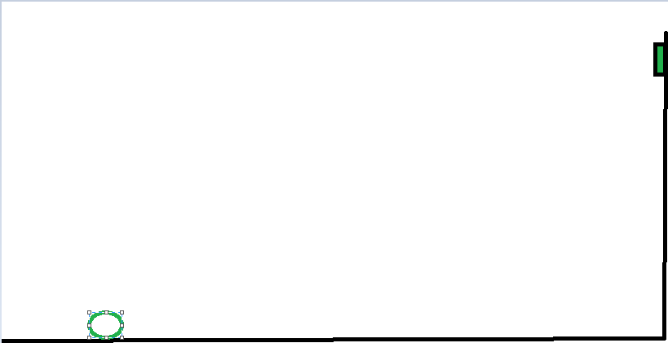

Level 2:

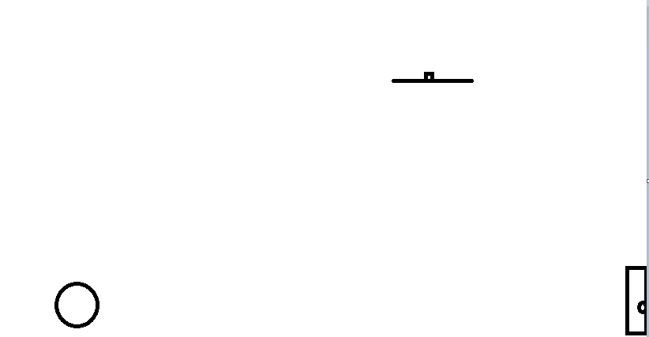

Level 3:

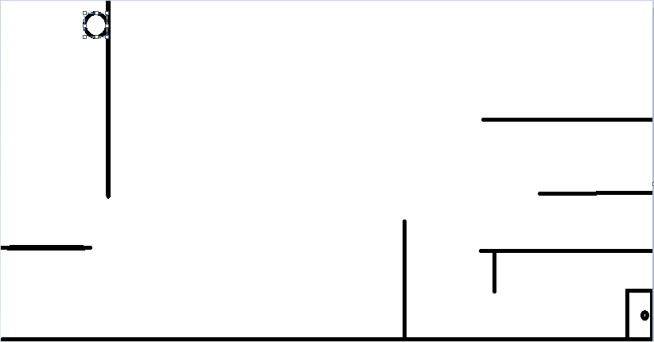

Level 4:

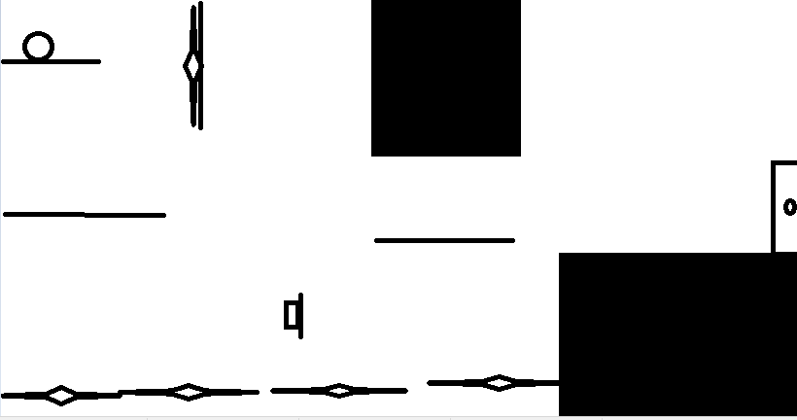

Level 5

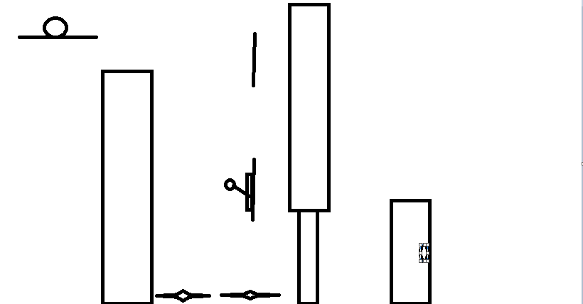

Level 6: